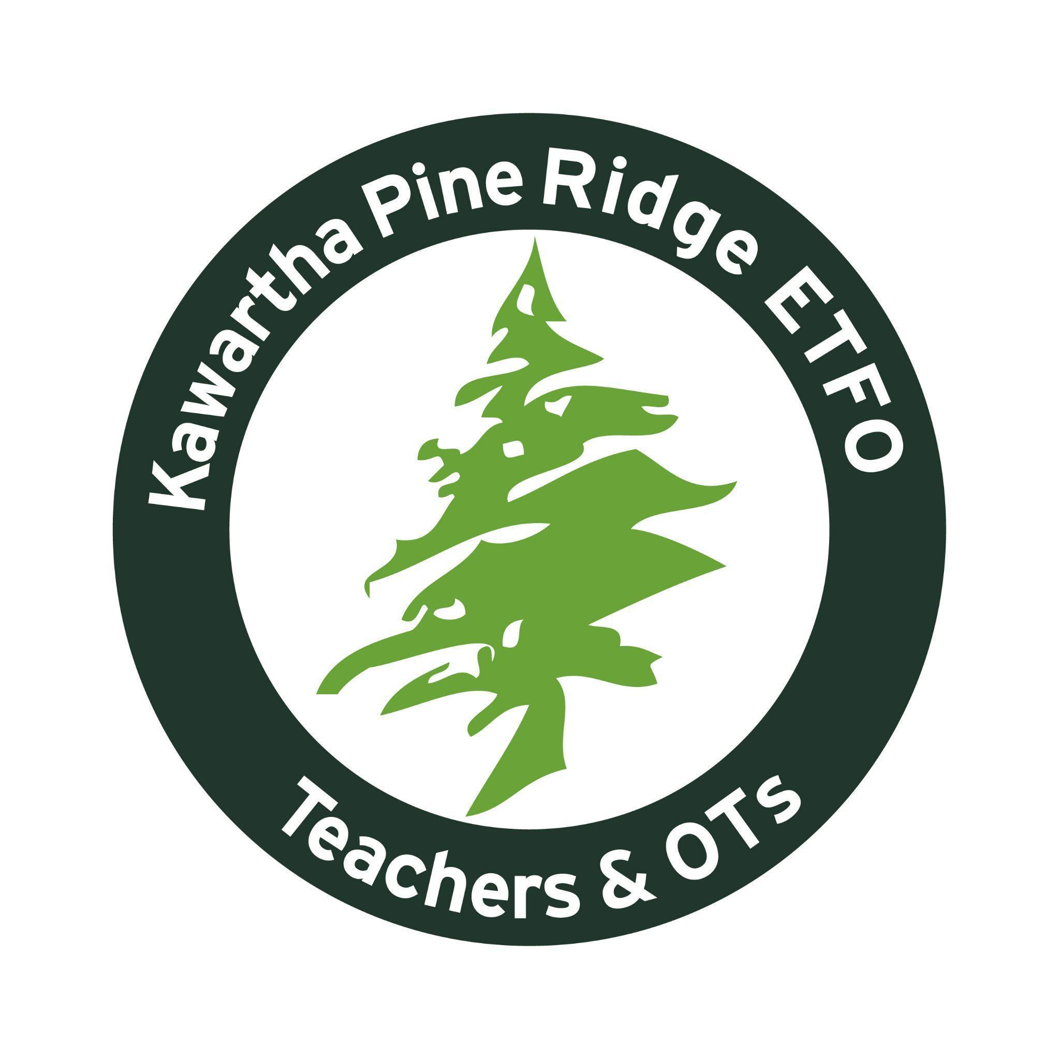

KPR ETFO Teacher Local

Donation Guidelines

As an organization, we receive many requests for funding. The goal of The Kawartha Pine
Ridge ETFO Teachers’ Local is to focus our donations on elementary-aged children, equally throughout the geography of the local, through the lens of the funding priorities.

KPR ETFO Funding Priorities
- To promote social justice in the areas of anti-poverty, non-violence, equity, and anti-racism.
- To promote the care and protection of the people in our communities.
- To support international assistance and cooperation.
- To promote the care and protection of the environment.
- To enhance the status and profile of elementary teachers and education workers.
- To promote and support public education and unionism.

Donations are given in accordance with the priorities listed in the Funding Priorities above.

1. All donation requests must be received on official organization letterhead (when applicable) and mailed, emailed or faxed to the Local office c/o the Local President. No requests shall be made by phone.
2. All donation requests must be accompanied by a signed KPR ETFO application form.
3. Each organization or individual may make a donation request once per school year.
4. All donation requests must be received at least one week prior to the date of the Local’s monthly Executive meeting which is posted on the Local calendar. The calendar can be found on the website.
5. All donation requests will be reviewed by the Executive, on a first come first served basis.
6. First-time requests may be given priority.
7. Requests will be approved considering equality throughout the geography of the Local.
8. We encourage members to be involved in their community and priority may be given to donation requests from members involved in these endeavours.
9. Approval will be granted, at the discretion of the Executive.
10. Donation requests will not exceed $500.00 per request. Exceptions to this amount may be made by the Executive.
11. Any donation requests to individual committees can be brought to the Executive by way of a motion and approved at a regular executive meeting.
12. KPR ETFO will consider donation requests for community families through local organizations and limit requests for direct family support to the families of KPR ETFO members.

Donation Application Form

Please complete and sign this application form and submit it to:

Kawartha Pine Ridge ETFO Teachers’ Local
2155A Davis Road
Cavan Monaghan, Ontario
K9J 0G5
admin@kpretfo.ca

Organization Representative or Individual Name
Mailing Address, Email, Website
Date of Application
Date Donation Required
Amount Requested
Description of event or project the funding will support
Your Organization’s Mission Statement
Describe how your event or project meets our Funding Priorities
Have you requested and received donations for this project from other sources?
Please specify.
Elementary Teachers’ Federation of Ontario Human Rights Statement:
The Elementary Teachers’ Federation of Ontario is committed to:
● providing an environment for members that is free from harassment and discrimination at all provincial and local Federation sponsored activities;
● fostering the goodwill and trust necessary to protect the rights of all individuals within the organization;
● neither tolerating nor condoning behaviour that undermines the dignity or self-esteem of individuals or the integrity of relationships; and
● promoting mutual respect, understanding and co-operation as the basis of interaction among all members

Harassment and discrimination on the basis of a prohibited ground are violations of the
Ontario Human Rights Code and are illegal. The Elementary Teachers’ Federation of Ontario will not tolerate any form of harassment or discrimination, as defined by the Ontario Human Rights Code, at provincial or local Federation sponsored activities.

Please sign indicating support of the ETFO Human Rights Statement.
Signature required for application to be considered.

